Status Report – Chess Bot

# What We’ve Completed

We’ve collected a new set of images with and without pieces on our new board for testing. These images are much better than the previous set, but could still be improved by a room with better lighting and a better quality mounted camera.

We’ve had to work on removing noise after testing with real images. Noise played had a big impact on board recognition, and made it hard to recover perspective. The team had to spend a lot of time dealing with noise removal and worst case scenario images.

We’ve figured out how to integrate GNU chess! GNU chess can take an FEN representation of the board as input to the program. FEN follows a pretty simple pattern that uses slashes to separate the different rows, upper and lower case letters to distinguish colors, and numbers to represent the total number of empty spaces between pieces. Once we convert the game state into FEN notation we can either call GNU chess from MatLab with the FEN as a command line argument, or send the FEN through a URL to nextchessmove.com, which uses GNU chess to calculate the next “best” move.

# What’s Gone Wrong

Adding the pieces to the board has added a new layer of complexity to the board recognition, and we often lose edges when pieces overlap, we had to spend a long time correcting this, and didn’t get as far on piece recognition as we would have liked. We’ve also had a few board and camera issues, and getting a mounted camera turned out to be harder than we thought, and after we created our amazing rig (see below), we realized we would need a better quality webcam. We also had a bit of a mishap with the board when I (Rob) sent the board home instead of to Rose.

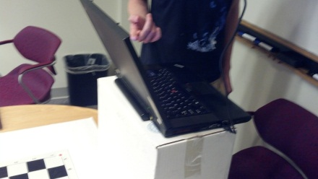 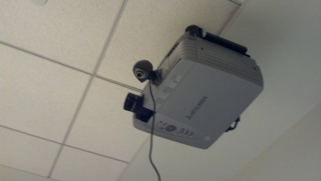

# What’s Left

Board recognition is working well, but we still need to finish piece recognition and use it to extract the game state. If we can complete these parts quickly this weekend, we will try to add more advanced features before our presentation on Monday. Our hope is that we will have a demo-able program that can calculate the next best move from static images of the board.